CSS
- Cascading Style Sheets 3
- Released in 1996 and maintained by
- Used to change look/feel of html elements (makeover)
Like color, background, border, alignment, wallpaper, animations, size of element, padding, margin, opacity etc…
- CSS provides only styles but not tags
- Style is group of properties or is a rule

Width=val height=val 🡸 html attributes
Width:val; height:val; 🡸 css properties

Where we can define styles?
We can define styles in 3 places (scope), those are:
- Inline styles
- Internal styles
- External styles

Different ways to implement css:
Inline (1st Approch)
Html tag and css properties both are defined within the same line
Syn:-
<tag style=”property:value; property:value; … “>

Unique style or personal styles

Internal (2ndApproch):
Html tags and css styles are designed in the same program, but not in same line.
Internal css should be implements in Style tag, style tag should be sub tag “head” tag (but we can also write in body section).
Syn:-
<style>
tag{
property:value;
property:value;
…….
}
tag{
property:value;
property:value;
…….
}
Etc…
</style>

Personal style but repeated applying

External (3rdApproch)
Css styles are defined in separate file and should be save with “.css”,
html code designed in separate file should be save with saved with “.html”
Use link tag for mapping css file to html file

Syn: <link rel=”stylesheet” href=”filename.css”/>

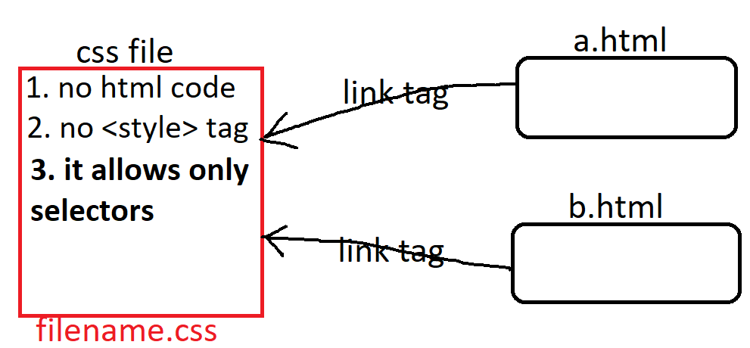

Global styles

note:
- css attributes we can't use in place of html attributes.
- html attributes we can't in place of css attributes.

html colors
html supports 3types of patterns, those are
> named colors
> RGB colors
> Hexadecimal colors

named colors:
>it supports to write direct color name
>we have some limited colors
ex: white, black, red, green etc...
>Color names are not case-sen
RGB colors:
>RGB model specifies that the composition of 3 basic colors (Red, Green, Blue)
>RGB produces 16millions colors.

Syn: rgb(red,green,blue)
red => 0 - 255
green => 0 - 255
blue => 0 – 255
ex: rgb(10, 45, 201) 401%255 🡺146

Hexadecimal number colors:
>Hexadecimal model is the shortcut for rgb model
>Hexadecimal system ranges from 0 - 15
0,1,2,3,4,5,6,7,8,9,a,b,c,d,e,f
Syn: #RRGGBB 1,2 red 3,4 green 5,6 blue
ex: #1a4b68
#RGB
ex: #3d7
Note: in realtime "Hexadecimal model" is recommended.

these colors we can use for foreground color, background color, border color
etc..
for setting colors we have some attributes, those are
color 🡺 to set/to change foreground color (text color)
background-color 🡺 to set/to change background color
border-color 🡺 to set/to change border color (line color)
box-shadow 🡺 to set/to change shadow color
text-shadow 🡺 to set/to change text shadow color
Note: all these are CSS attributes. Support by Most of html tags

Gradient colors
background: #FC466B; /* fallback for old browsers */
background: -webkit-linear-gradient(to bottom, #3F5EFB, #FC466B); 🡸 Chrome 10-25, Safari 5.1-6
background: linear-gradient(to bottom, #3F5EFB, #FC466B); 🡸W3C, IE 10+/ Edge, Firefox 16+, Chrome 26+, Opera 12+, Safari 7+

linear-gradient(direction, color1,color2,…color-n)
dir: to left (r=>l)
to right (l=>r)
to top (b=>t)
to bottom (t=>b)

background: linear-gradient(to bottom, #3F5EFB 40%, #FC466B 60%);

-webkit-linear-gradient(to left, #3F5EFB, #FC466B);
linear-gradient(to left, #3F5EFB, #FC466B);

background: radial-gradient(circle, rgba(2,0,36,1) 0%, rgba(38,38,162,1) 60%, rgba(0,212,255,1) 100%);

radial-gradient(shape, color1, color2, …color-n)

radial-gradient(circle, rgb(131,58,180) 0%, rgb(29,166,65) 50%, rgb(252,176,69) 100%);

radial-gradient(circle, rgba(166,29,142,1) 57%, rgba(100,180,111,1) 78%, rgba(69,252,96,1) 100%);
Note: while applying gradient colors we have to use “background” property in place of “background-color”.

opacity: 0.5;
filter: blur(5px);
brightness(125%)
contrast(135%)
grayscale(100%)
invert(100%)
hue-rotate(180deg)
saturate(8)
sepia(100%)
drop-shadow(8px 8px 10px green)

